UNIFORM RESOURCES GUIDE

PRE-APPROVED RESOURCES FOR CADET-SUPPLIED UNIFORM ITEMS:

**A note on gender specific items - we have identified uniform items that are male/boys. For consistency in appearance and quality of make, all cadets - male or female - can wear these. Females may wear the male/boy fit or the optional female fit (where exists) if needed.

BOTH LEAGUE CADETS AND SEA CADETS: BOOTS, DRESS SHOES, HYDRATION

Black oxford lace-up dress shoes. No corforms or patent shines please. No decorative stitching or design (if possible). Style should be similar to these examples below. Dress shoe example - lace up black as plain as possible!

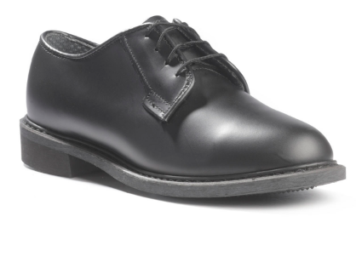
Examples -
https://militaryuniformsupply.com/products/rothco-military-uniform-oxford-leather-shoes?variant=11990478389284&utm_medium=cpc&utm_source=google&utm_campaign=Google%20Shopping&cid=1896573835&aid=71700948178&keyword=296303633664%3A%3Apla-296303633664&kid=296303633664&gclid=CjwKCAjw5p_8BRBUEiwAPpJO6ynb0jf0o9VEliZK7s-HVdKSJ1WCoYOY4I-WWmKmyEdTWYREzsLHBxoCf1wQAvD_BwE

https://www.dsw.com/en/us/product/first-semester-nayma-oxford---kids/468727?cm_mmc=CSE-_-GPS-_-G_Shopping_Evening%20%26%20Wedding-_-New_Evening%20%26%20Wedding&cadevice=c&gclid=Cj0KCQjwsuP5BRCoARIsAPtX_wF2_gJDFG2GUPPNa9Mp4DCW79VX8_t6nywnZ8U_HckW82LvN5c7gigaAndTEALw_wcB&gclsrc=aw.ds

https://www.armysurplusworld.com/military-oxford-shoes

Black, military/tactical style boots and dress shoes. We try to issue boots and dress shoes to all cadets if we have a proper size available. This is not part of the issued uniform under your enrollment fee. We recommend the following places if we cannot find a boot or shoe to fit your cadet. Many parents have good luck searching for boots at Army-Navy surplus stores and similar and can be more affordable.

Special to League Cadets -- due to difficulty in obtaining for very small sizes, all black high ankle athletic shoes (not basketball/converses) may be permitted for League cadets only. As your cadet grows, we will always attempt to boot them with on-hand supplies if we can. Boots should be 8 inches high, black and have the ability to be shined. ABSOLUTELY NO ZIPPERS ON BOOTS AND NO BROWN BOOTS!!! Some examples:

Some options for military boots -

https://militaryuniformsupply.com/collections/military-boots/products/rothco-gi-style-jungle-boots

https://www.armynavyoutdoors.com/ (for new) - they have sizes down to 2 for (all black) military boots for $32 and have some in stock right now. 127 Monument Road,Jacksonville, Florida 32225Phone: (904) 725-5000.

http://www.thesupplybunker.com/clothing (for used and new) - 1280 Blanding Blvd, Orange Park, FL 32065; Phone (904) 375-9795 – Have to call or physically visit the store for selection.

https://www.facebook.com/aarmynavydepot1/ (used) - 4721 San Juan Ave, Jacksonville, Florida, Phone (904) 388-7113 – Facebook page, must call or visit location for selections.

https://www.academy.com/shop/pdp/tactical-performance-mens-hawk-8-in-tactical-boots#repChildCatid=6338609

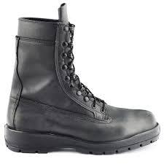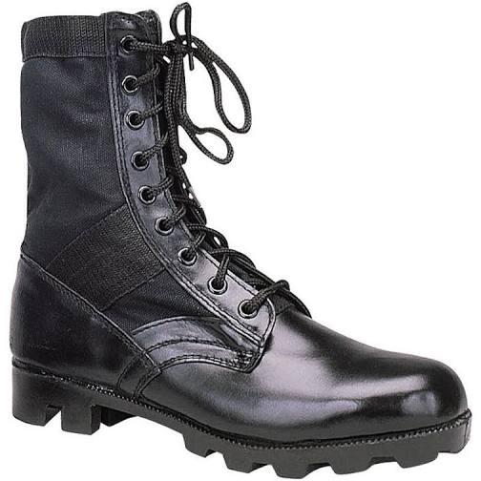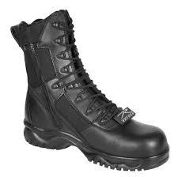

LEAGUE CADETS ONLY –
White short sleeve blouse (summer dress white uniform)
Flat front black pants (summer and dress blue uniform – one pair can be used for both uniforms)

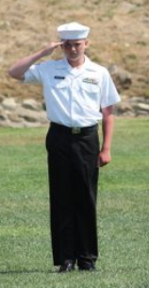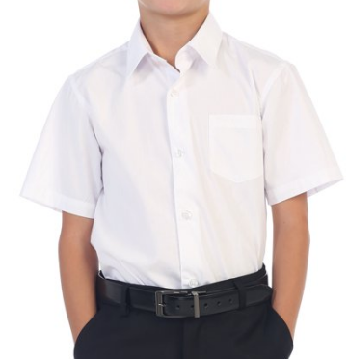
No button downs or “oxford style”

White short-sleeved dress shirt with pocket (no “button down” collars!). The following are PRE-APPROVED:

Walmart - https://www.walmart.com/ip/Gioberti-Boy-s-Short-Sleeve-Solid-Dress-Shirt/384223500?athcpid=384223500&athpgid=athenaItemPage&athcgid=null&athznid=PWVUB&athieid=v0&athstid=CS004&athguid=d8961653-007-173f957d50d8b6&athancid=null&athena=true

French Toast (Amazon) https://www.frenchtoast.com/product/short+sleeve+classic+dress+shirt+toddler+2t-4t.do?sortby=ourPicks&from=fn

Kohls - https://www.kohls.com/product/prd-3523747/mens-croft-barrow-classic-fit-easy-care-spread-collar-dress-shirt.jsp?color=White%20Spread%20Collar&prdPV=3

Optional for females - although we again recommend the male shirts if female will fit:
https://www.frenchtoast.com/product/short+sleeve+pointed+collar+girls+uniform+blouse+4-6x.do?sortby=ourPicksAscend&from=fn

https://www.amazon.com/Dickies-Womens-Stretch-Poplin-Button-Up/dp/B07NM26QDV/ref=sr_1_26?dchild=1&keywords=short+sleeve+white+women+dress+shirt&qid=1597617522&s=apparel&sr=1-26

DO NOT GET WIDE CUFFED SLEEVES LIKE THIS!!!!!

================================================
Black formal, flat front trousers (no cuffs, reinforced knees, jeans). Must be able to crease down middle. We recommend females get the male pant as there are no good female equivalent.
Examples of pant, comfort stretch and (black) khaki regular. All flat front:

Walmart -The following are PRE-APPROVED:
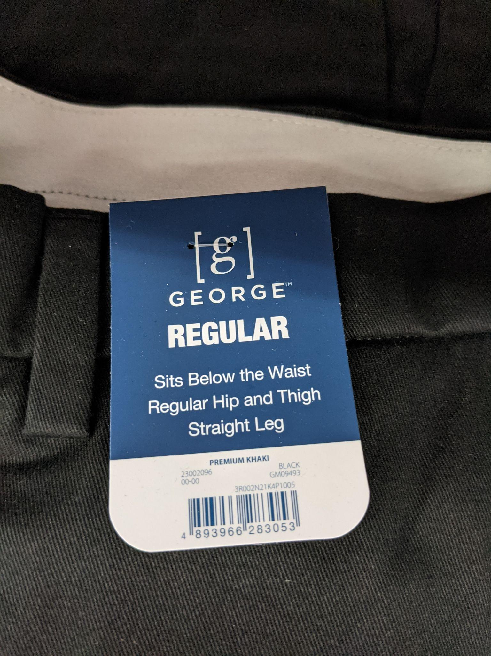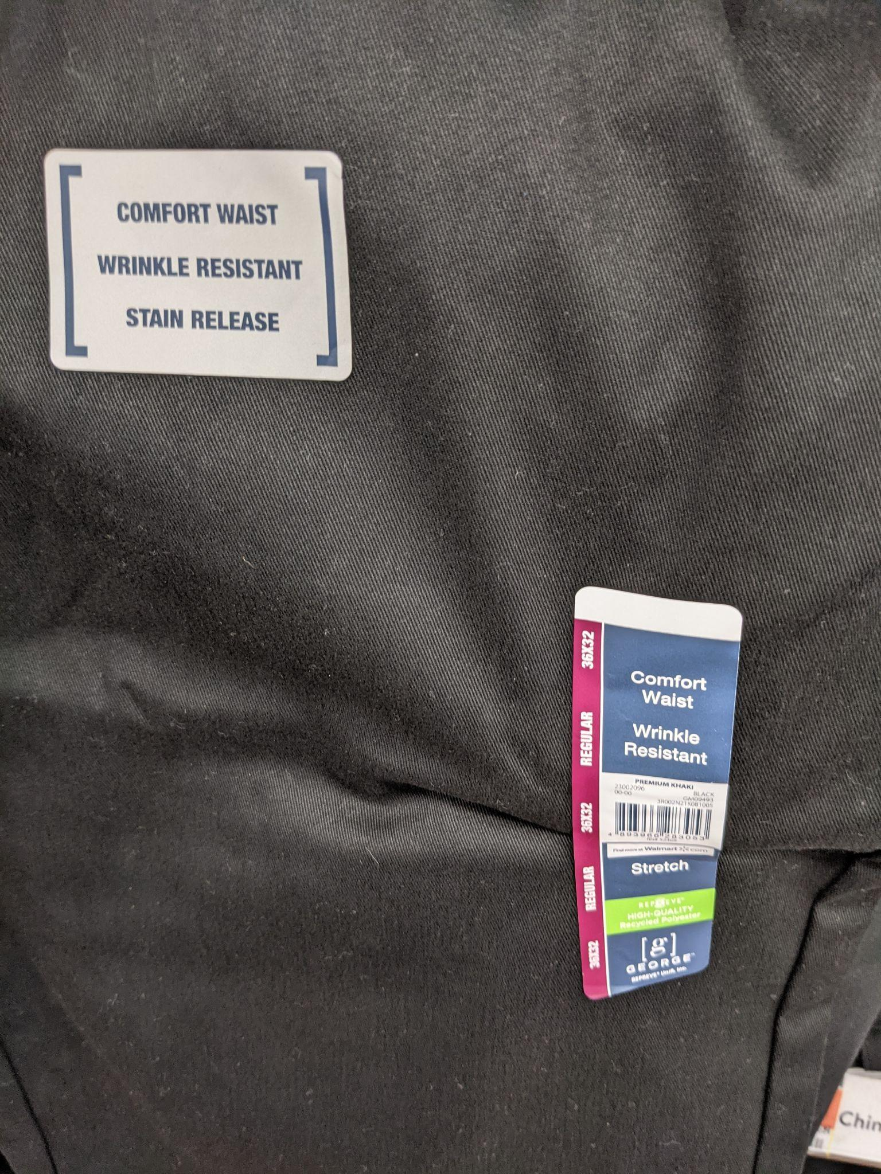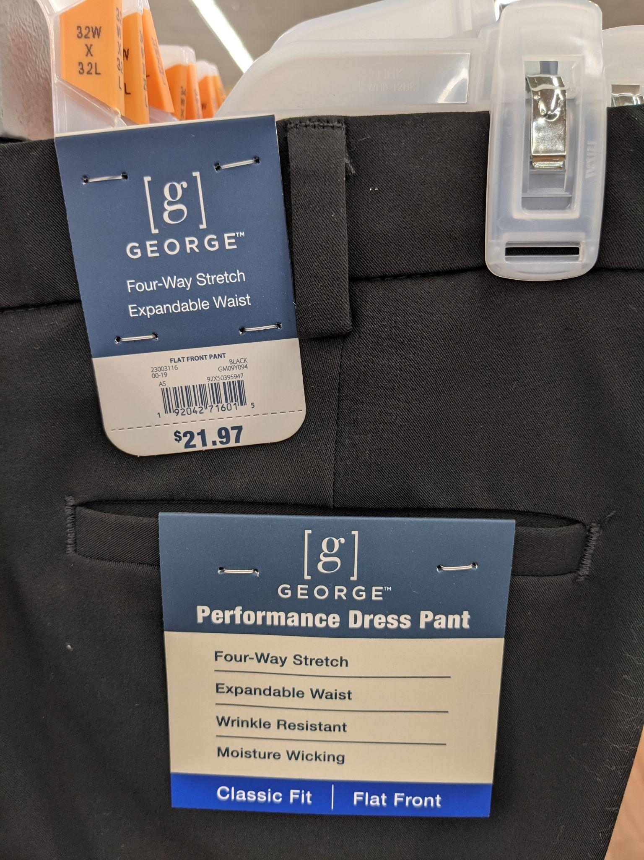
#1 recommendation Walmart - “George” brand - they come in performance dress.

Other options:
https://www.frenchtoast.com/product/adjustable+waist+pant+%28modern+fit%29+boys+4-7.do?sortby=ourPicksAscend&from=fn

https://www.target.com/p/boys-suit-pants-cat-jack-8482-black-10/-/A-50769611?ref=tgt_adv_XS000000&AFID=google_pla_df&fndsrc=tgtao&CPNG=PLA_Kids%2BShopping_Local&adgroup=SC_Kids&LID=700000001170770pgs&network=g&device=c&location=9011561&ds_rl=1246978&ds_rl=12469

Optional for females - again, we recommend getting the male pant but if female does not fit, try these::
https://www.amazon.com/Bienzoe-School-Uniforms-Cotton-Stretchy/dp/B075R1DVLM/ref=sr_1_2_sspa?ie=UTF8&qid=1546360744&sr=8-2-spons&keywords=girls+flat+front+uniform+pants&psc=1

https://www.amazon.com/Dickies-Girls-Stretch-12-Regular/dp/B00NAWUSMK/ref=sr_1_10?ie=UTF8&qid=1546360744&sr=8-10&keywords=girls+flat+front+uniform+pants

https://www.target.com/p/girls-stretch-uniform-ponte-pants-cat-jack-black/-/A-79415293?preselect=78779110#lnk=sametab

